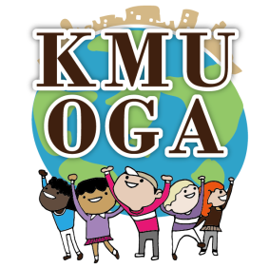
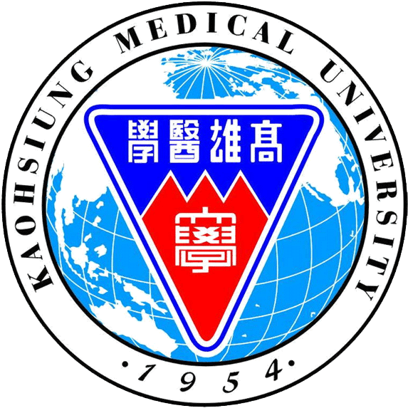
Date: 1st Novembe r 2014
KMU-OGA
Proudly Presents
Deepavali Celebrations @ Kaohsiung 2014
Time: 16:30 – 20:00
Place: CS-B201 Auditorium
Purpose: Deepavali also known as Diwali is a "festival of lights" and a most important Indian’s ancient festival. The myth and story of this festival lies the victory of good over evil. We celebrate here in Kaohsiung for the first time with fun filled events to share the cultural heritage of India.
Schedule
Time | Content
14:00~16:00 | Prepare
16:00~16:30 | Sign up
16:30~16:40 | Prayer song
16:40~17:00 | Welcome Speech
17:00~17:30 | Festival Introduction(Deepavali)
17:30~19:00 | Dancing performance
19:00~21:00 | Traditional Indian Dinner
21:00~22:00 | Clean up
~We cordially invite you all to come and join us~
Kaohsiung Medical University
Office of Global Affairs
MOE Grant for Encouraging Teaching excellence and Youth Development Administration

