2018 International Volunteer Camp in Penghu
Program Name: Why don't you come over ? ─Penghu International WorkCamp
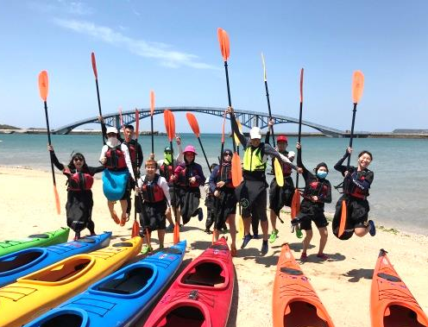
- Background:
Situated in the Taiwan Strait between Taiwan and the Mainland China, Penghu is the largest island archipelago of Taiwan. Featuring its azure sea and bright sunshine, Penghu consists of 97 islands and islets, and the nearest one is only about 50 km away from Taiwan. In the 16th century, the Portuguese colonists found that there were a great number of fishermen, thus they called Penghu as “The Fisherman Island”. The remote location and its geological conditions profoundly influence its traffic, population and industry structure. Penghu thus becomes a place isolated from intercultural communication and can only receive limited resources. Most Penghu teenagers can only know information about foreign countries/cultures through mass media. Even people living in main islands have limited chance, not to mention those children in financially challenged families or people living in even more distant islands.
TFCF Penghu branch office was established in 1965, and the main focus is to support children whose family encountered accidents or having economic hardship. Children under abused are also the target of intervention and protecting. Currently, TFCF provides financial supports to these children, hoping to meet their daily needs and to grant their rights of education and living. If we are able to give them chances of dedicating their efforts to the society or communicating with foreign cultures, we will be able to strengthen their confidence and identity. On the other hand, they will be more willing to help others and be more capable of dealing with foreign cultures and social issues.
“Where there is a child in need, there is TFCF.” This motto is always the core concept of TFCF. Besides accompanying family in financial diffculities, TFCF also devloped a series of course to help children deal with the fast-changing society. Financial hardships, stress from both mentally and physically, the lack of resources due to the remote location, and the pressure from society will more and less influence capacity and confident of children. These factors may further lead to low social participation and the low capability of reacting with social issues. Starting from 2010, TFCF Penghu has been cooperating with interantional socail workers to provide more services to the youth. TFCF now provides servies not only finiacial supports, but also providing children chances for studying. By doing so, these children are more likely to respond to social issues and understand more about the society. Moreoever, TFCF also coopeates with commuity revival project, providing various supports to help childern develop their advantages, solve difficulites their families had encountered, strengthen community recognition, and find out the feature of the community.
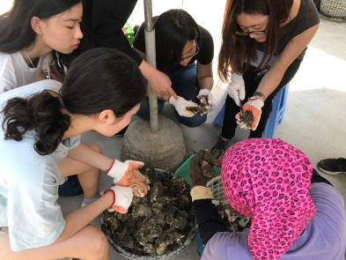
The International Voluteer Camp will provide these services to the remote areas of Baisha and Xiyu. This will be a chance for local children to interact with teenagers from all around the world. Through the pre-camp courses and the activites during the camp, the enhancing understanding of their hometown and the strengthened planning and cooperation abilites are expected. The camp and courses are expected to be helps in the childrens’ future.

- Program objectives and objectives
- Recruiting 8 international volunteers who are interested in Taiwanese culture and are willing to serve in distant islands .There will be 8 foreign volunteers and 2 Taiwanese Volunteer working as deputy coordinator of the whole program.
- Developing the children’s and international volunteers’ abilities of planning activities and team spirit through the pre-camp training courses
- With a 8-day camp design, promote poverty Reduction and International Volunteer Multicultural Understanding and Exchange, Expanding International Vision.
- Enhancing the awareness and recognition of local communities of local youth volunteers and international volunteer through community visits and social services.
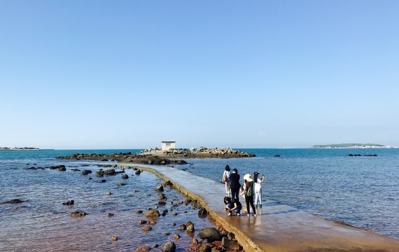
- The program schedule:
- 2018.02.28 Recruitment deadline
- 2018.03.03-04 Selection interview
- 2018.03.09 Announced result
- 2018.03.24-25 International volunteer training
- 2018.02-2018.06 Preparation (Activity planning and teamwork training)
- 2018.07.09-2018.07.16 Implementation period－Camp Start !

- The Location of implementation:
TFCF Penghu Branch Office、Penghu Island(Baisha and、Xiyu township)
- Participants and number of participants:
staff member | Number | Work
Social workers〈Ou-ling Gu、Yi-chen Lin、Ching-chu Yeh〉 | 3 | Event planning、Administration coordination、Volunteer contacting、Funds management。
Deputy leaders (TFCF University Volunteer ) | 2 | Leading activities、Dealing with meals and all kinds of tasks、Administration assistance.
Foreign volunteers | 8 | Camp planning、Executing activities、Administration assistance、community service。
Baisha、Xiyu local youths volunteers | 20

- Camp Schedule

Since 2017.12 Program social worker respectively at the university in Taiwan、Penghu island Baisha township、Xiyu township get on program volunteers and Member recruitment . And from March to June of this year, we will carry out relevant training and plan preparation.
date | location | content
7/08 | TFCF Penghu Branch Office | International volunteers will arrive in Penghu，and they will know their way around the TFCF Penghu Branch Office and living space.
7/09 | TFCF Penghu Branch Office | Preparation before the work camp.
7/09-7/10 | TFCF Penghu Branch Office、Penghu island | International volunteers and local youth volunteers will be introduced to each other, and they will be divided in groups for community services and their designated task.
7/11-7/13 | Penghu Baisha township | Visiting and understanding the community, cultural exchanges, experiencing local culture.
7/14-7/16 | Penghu Xiyu township
7/16 | TFCF Penghu Branch Office | Farewell party
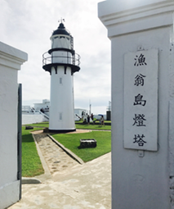
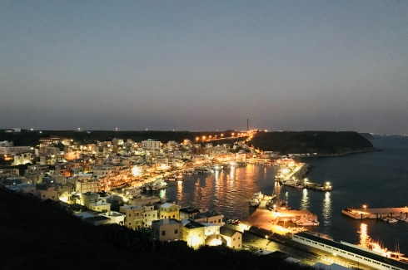
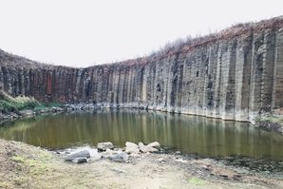

- Budget:
1. The program is financed by the TFCF, which covers all activities during the camp preparation and during the implementation.
2. However, volunteers have to pay
(1) The round-trip transportation cost between Penghu and Taiwan
(2) Any personal expenses in the free time.

