國際外賓來訪行程表-範例
日期 | 時間 | 行程內容 | 地點 | 參與人員 | 備註
2023.  01.10 | 09:00-09:30 | 歡迎接待 | 國研大樓1F | 校方代表: _______________  學院代表: _______________
 | 09:30-10:00 | 拜會首長 | 國研大樓9F | 校方代表: _______________  學院代表: _______________ | 致贈  校級禮物
 | 10:00-12:00 | 交流座談 | 勵學大樓4F會議室 | 學院代表: _______________
 | 12:00-14:00 | 午宴 | 餐廳地點 | 校方代表: _______________
 | 14:00-16:00 | 附設醫院  參訪 | 附設醫院 | 附設醫院行政室人員: _______________
 | 16:00-17:00 | 校史館  參訪 | 高醫校史館 | 校史館導覽人員: _______________

(來訪大學名稱及日期) Visit KMU itinerary

Date | Time | Schedule | Venue | Attendee | Note
2023.  01.10 | 09:00-09:30 | Welcome | International Academic Research Building1F | School-delegate:  College-delegate:
 | 09:30-10:00 | Meeting with President | International Academic Research Building 9F | School-delegate:  College-delegate:
 | 10:00-12:00 | Meeting with college of | International Academic Research Building 4F  Meeting Room 2 | College-delegate:
 | 12:00-14:00 | Welcome Lunch |  | School-delegate:  College-delegate:
 | 14:00-16:00 | Visit KMUH | KMUH | KMUH Division of Secretariat
 | 16:00-17:00 | Visit Museum of KMU historic | Medical Building | Guided tour

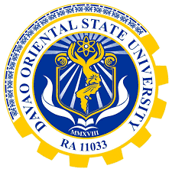
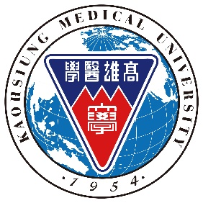
Agenda
Online Meeting between
Kaohsiung Medical University
and
Davao Oriental State University

Date: Wednesday, Aug. 4th, 2021
Google Meet Link: https://meet.google.com/wza-avmd-jra

Delegates
Delegates from Davao Oriental State University (DOrSU)
Dr. Lilibeth Galvez, Professor of Institute of Agriculture and Life Sciences / Director of International Relations Office
Dr. Wilanfranco C. Tayone, Vice President for Research Development & Extension
Dr. Saturnino E. Dalagan Jr., Vice President for Academic Affairs
Cirilo O. Ybanez, Jr., Program Head of the BS in Biology
Dr. Eleanor M. Vilela, Program Heads of the BS in Environmental Science
IRO Staff: Arvin Jay P. Costales and Carlos Jae D. Soliven

Delegates from Kaohsiung Medical University (KMU)
Dr. Yih-Fung Chen, Director of Academic Collaboration, Office of Global Affairs / Assistant Professor of Graduate Institute of Natural Products, College of Pharmacy
Dr. Yong-Chao Su, Assistant Professor of Department of Biomedical Science and Environment Biology on behalf of College of Life Science
OGA Staff: Joy Chang

Agenda
Time | Activity | By
15:00-15:05  (5 min.) | -Greeting and Introducing the Participants | Director Yih-Fung Chen
15:05-15:15  (10min.) | - Introduction of DOrSU | Director Lilibeth Galvez
15:15-15:20  15:20-15:25  (5 min. each) | - Introduction of KMU  -Introduction of College of Life Science | Director Yih-Fung Chen  Assistant Professor Yong-Chao Su
15:25-16:00  (35 min.) | -Panel Discussion  -Group Photo | All Participants

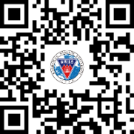
KMU 2022 Spring Education Fair (Online)
March 16th, 2022
Time: 9:00 (GMT+8 Taiwan & Indonesia)
Google Meet: meet.google.com/jfm-qrmo-mvz

AIM: The aim of this educational fair is to establish a firm and long term relationship between Sam Ratulangi University (UNSRAT) and Kaohsiung Medical University(KMU) in terms of education, teaching and research collaboration.

PARTICIPANTS: Lecturers from UNSRAT Faculty Medicine (general medicine, dentistry, nursing departments), Faculty of Mathematics and Sciences (pharmacy department), and Faculty of Public Healthcare are kindly invited to join this event.

AGENDA
Taiwan Indonesia  (GMT+8)  Duration | Session | Speaker | Moderator
9:00-9:05  5 mins | Opening Remarks | KMU Vice President for  Global Affairs  Prof. Cheng-Che Eric Lan  Head of International office  Sam Ratulangi University  Dr. Ir. Reiny A. Tumbol, M.Apps.Sc | Dean Lee  Of CoN
9:05-9:20  15 mins | KMU College of Nursing | Dean & Prof. Bih-O Lee | Dean Lee  Of CoN
9:20-9:35  15 mins | KMU College of  Dental Medicine | Director & Prof. Ying-Chu Lin  Int’l Affairs, CoDM | Dean Lee  Of CoN
9:35-9:50  15 mins | KMU College of Medicine | Director & Prof. Bin-Nan Wu  Graduate Institute of Medicine | Dean Lee  Of CoN
9:50-10:05  15 mins | KMU College of Life Science | Director & Prof. Genin Gary Huang  Int’l Affairs, CoLS | Dean Lee  Of CoN
10:05-10:10  5 mins | Closing Remarks | Dean & Prof. Bih-O Lee  College of Nursing
Office of Global Affairs, Kaohsiung Medical University, Taiwan
T: +886 (0)7 312-1101 ext. 2383
F: +886 (0)7 322-0004
http://ciae2.kmu.edu.tw

